**SMART WATER FOUNTAIN :**

***During the past decade, water needs have increased unpredictably in India. Increasing demand of water supply has become a major challenge for the world. Wasteful usage of water, climatic changes and Urbanization has further depleted the resource. Conservation and management of the resource must be given utmost importance. In this paper, we present an IoT design for water monitoring and control approach which supports internet based data collection on real time bases. The system addresses new challenges in the water sector -flow rate measuring and the need for a study of the supply of water in order to curb water wastage and encourage its conservation. We also measure the quality of water distributed to every household by deploying pH and conductivity sensors. The traditional water metering systems require periodic human intervention for maintenance making it inconvenient and often least effective.For shortcoming of the existing models for a ubiquitous usage of wireless systems for smart quality monitoring and communicate data wirelessly***

**FLOWCHART FOR SMART WATER MANAGEMENT:**

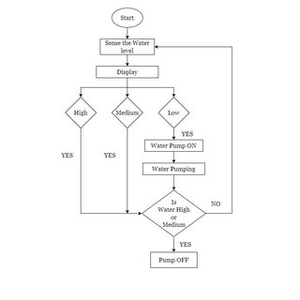

**Smart water fountain**

***If you leave your pets alone at home for***

***prolonged periods of time, the smart TESLA fountain will provide***

***them with a constant supply of fresh drinking water for up to 5 days.***

***You can conveniently operate it remotely via an app, but it can also work in a fully automatic mode.***

**Attributes:**

* ***Customer id:***

***It implies the customer ID.***

* ***Region:***

***A region is an area of land that has common features.***

* ***Payment:***

***Payment is the voluntary transfer of money, equivalent, or other valuable items from one person to another in exchange for goods or services received or to meet a legal obligation.***

* ***Transaction code:***

***Transaction codes represent the various bank transactions that you will use in the Accounts Payable and Accounts Receivable applications.***

* ***Source:***

***Something or someone that causes or produces something, or is the origin of it.***

* ***Amount:***

***Value of the product it implies in $ or indian rupee.***

* ***Product:***

***A product is any item or service you sell to serve a customer's need or want.***

* ***Time of the day:***

***The time according to the clock. A loosely specified period of time, minutes or hours in duration, especially daytime, or point in time.***

***Smart water fountain :***

|  |  |  |  |  |  |  |
| --- | --- | --- | --- | --- | --- | --- |
| **Cust ID** | **Region** | **Payment** | **Transaction Code** | **Source** | **Amount** | **Product** |
| 10001 | east | paypal | 938916545 | Web | $20.19 | DVD |
| 10002 | west | credit | 740183490 | Web | $17.85 | DVD |
| 10003 | north | credit | 649423681 | Web | $23.98 | DVD |
| 10004 | west | paypal | 70560957 | Email | $23.51 | Book |
| 10005 | south | credit | 35208817 | Web | $15.33 | Book |
| 10006 | west | paypal | 20978903 | Email | $17.30 | DVD |
| 10007 | east | credit | 80103311 | Web | $177.72 | Book |
| 10008 | west | credit | 14132683 | Web | $21.76 | Book |
| 10009 | south | paypal | 40128225 | Web | $15.92 | DVD |
| 10010 | south | paypal | 49073721 | Web | $23.39 | DVD |
| 10011 | east | paypal | 57398827 | Email | $24.45 | Book |
| 10012 | north | credit | 34400661 | Web | $20.39 | Book |
| 10013 | east | paypal | 54242587 | Web | $19.54 | DVD |
| 10014 | west | credit | 62597750 | Web | $151.67 | Book |
| 10015 | west | credit | 51555882 | Web | $21.01 | DVD |
| 10016 | west | paypal | 54332964 | Web | $22.91 | DVD |
| 10017 | west | credit | 26623353 | Email | $19.51 | Book |
| 10018 | west | paypal | 78594431 | Web | $20.16 | Book |
| 10019 | west | credit | 893785348 | Web | $17.53 | DVD |
| 10020 | north | credit | 69898417 | Web | $17.74 | DVD |
| 10021 | west | paypal | 59660276 | Email | $17.16 | Book |
| 10022 | south | credit | 25456590 | Web | $205.58 | Book |
| 10023 | west | credit | 93283893 | Email | $18.12 | Book |
| 10024 | west | credit | 45991123 | Web | $20.04 | DVD |
| 10025 | west | paypal | 79121745 | Email | $23.21 | DVD |
| 10026 | west | credit | 89685117 | Email | $22.79 | DVD |
| 10027 | west | credit | 56689474 | Web | $16.91 | DVD |
| 10028 | south | credit | 25270813 | Web | $20.22 | Book |
| 10029 | east | paypal | 59736137 | Web | $18.36 | DVD |
| 10030 | west | paypal | 79615191 | Email | $206.80 | Book |
| 10031 | north | paypal | 55365094 | Email | $17.95 | DVD |
| 10032 | east | credit | 79118930 | Web | $18.29 | Book |
| 10033 | south | paypal | 84470584 | Web | $18.55 | Book |
| 10034 | west | credit | 71097636 | Web | $18.82 | Book |
| 10035 | south | credit | 9962217182 | Web | $20.19 | DVD |
| 10036 | east | paypal | 938916545 | Web | $17.85 | DVD |
| 10037 | west | credit | 740183490 | Web | $23.98 | DVD |
| 10038 | north | credit | 649423681 | Email | $23.51 | Book |
| 10039 | west | paypal | 70560957 | Web | $15.33 | Book |
| 10040 | south | credit | 35208817 | Email | $17.30 | DVD |
| 10041 | west | paypal | 20978903 | Web | $177.72 | Book |
| 10042 | east | credit | 80103311 | Web | $21.76 | Book |

|  |  |  |  |  |  |  |
| --- | --- | --- | --- | --- | --- | --- |
| 10043 | west | credit | 14132683 | Web | $15.92 | DVD |
| 10044 | south | paypal | 40128225 | Web | $23.39 | DVD |
| 10045 | south | paypal | 49073721 | Email | $24.45 | Book |
| 10046 | east | paypal | 57398827 | Web | $20.39 | Book |
| 10047 | north | credit | 34400661 | Web | $19.54 | DVD |
| 10048 | east | paypal | 54242587 | Web | $151.67 | Book |
| 10049 | west | credit | 62597750 | Web | $21.01 | DVD |
| 10050 | west | credit | 51555882 | Web | $22.91 | DVD |
| 10051 | west | paypal | 54332964 | Email | $19.51 | Book |
| 10052 | west | credit | 26623353 | Web | $20.16 | Book |
| 10053 | west | paypal | 78594431 | Web | $17.53 | DVD |
| 10054 | west | credit | 893785348 | Web | $17.74 | DVD |
| 10055 | north | credit | 69898417 | Email | $17.16 | Book |
| 10056 | west | paypal | 59660276 | Web | $205.58 | Book |
| 10057 | south | credit | 25456590 | Email | $18.12 | Book |
| 10058 | west | credit | 93283893 | Web | $20.04 | DVD |
| 10059 | west | credit | 45991123 | Email | $23.21 | DVD |
| 10060 | west | paypal | 79121745 | Email | $22.79 | DVD |
| 10061 | west | credit | 89685117 | Web | $16.91 | DVD |
| 10062 | west | credit | 56689474 | Web | $20.22 | Book |
| 10063 | south | credit | 25270813 | Web | $18.36 | DVD |
| 10064 | east | paypal | 59736137 | Email | $206.80 | Book |
| 10065 | west | paypal | 79615191 | Email | $17.95 | DVD |
| 10066 | north | paypal | 55365094 | Web | $18.29 | Book |
| 10067 | east | credit | 79118930 | Web | $18.55 | Book |
| 10068 | south | paypal | 84470584 | Web | $18.82 | Book |
| 10069 | west | credit | 71097636 | Web | $20.19 | DVD |
| 10070 | south | credit | 9962217182 | Web | $17.85 | DVD |
| 10071 | east | paypal | 938916545 | Web | $23.98 | DVD |
| 10072 | west | credit | 740183490 | Email | $23.51 | Book |
| 10073 | north | credit | 649423681 | Web | $15.33 | Book |
| 10074 | west | paypal | 70560957 | Email | $17.30 | DVD |
| 10075 | south | credit | 35208817 | Web | $177.72 | Book |
| 10076 | west | paypal | 20978903 | Web | $21.76 | Book |
| 10077 | east | credit | 80103311 | Web | $15.92 | DVD |
| 10078 | west | credit | 14132683 | Web | $23.39 | DVD |
| 10079 | south | paypal | 40128225 | Email | $24.45 | Book |
| 10080 | south | paypal | 49073721 | Web | $20.39 | Book |
| 10081 | east | paypal | 57398827 | Web | $19.54 | DVD |
| 10082 | north | credit | 34400661 | Web | $151.67 | Book |
| 10083 | east | paypal | 54242587 | Web | $21.01 | DVD |
| 10084 | west | credit | 62597750 | Web | $22.91 | DVD |
| 10085 | west | credit | 51555882 | Email | $19.51 | Book |

|  |  |  |  |  |  |  |
| --- | --- | --- | --- | --- | --- | --- |
| 10086 | west | paypal | 54332964 | Web | $20.16 | Book |
| 10087 | west | credit | 26623353 | Web | $17.53 | DVD |
| 10088 | west | paypal | 78594431 | Web | $17.74 | DVD |
| 10089 | west | credit | 893785348 | Email | $17.16 | Book |
| 10090 | north | credit | 69898417 | Web | $205.58 | Book |
| 10091 | west | paypal | 59660276 | Email | $18.12 | Book |
| 10092 | south | credit | 25456590 | Web | $20.04 | DVD |
| 10093 | west | credit | 93283893 | Email | $23.21 | DVD |
| 10094 | west | credit | 45991123 | Email | $22.79 | DVD |
| 10095 | west | paypal | 79121745 | Web | $16.91 | DVD |
| 10096 | west | credit | 89685117 | Web | $20.22 | Book |
| 10097 | west | credit | 56689474 | Web | $18.36 | DVD |
| 10098 | south | credit | 25270813 | Email | $206.80 | Book |
| 10099 | south | paypal | 59736137 | Email | $17.95 | DVD |
| 10100 | west | credit | 814847505 | web | $18.64 | DVD |

|  |  |  |
| --- | --- | --- |
| **Time of Day** |  |  |
| 22 19 |  |  |
| 13 27 |  |  |
| 14 27 |  |  |
| 15 38 |  |  |
| 15 21 |  |  |
| 13 11 |  |  |
| 21 59 |  |  |
| 4 04 |  |  |
| 19 35 |  |  |
| 13 26 |  |  |
| 14 17 |  |  |
| 1 01 |  |  |
| 10 04 |  |  |
| 9 09 |  |  |
| 5 05 |  |  |
| 20 29 |  |  |
| 15 03 |  |  |
| 18 54 |  |  |
| 20 00 |  |  |
| 12 37 |  |  |
| 5 05 |  |  |
| 2042 |  |  |
| 10 12 |  |  |
| 16 27 |  |  |
| 20 22 |  |  |
| 19 58 |  |  |
| 1944 |  |  |
| 19 28 |  |  |
| 1548 |  |  |
| 18 14 |  |  |
| 15 15 |  |  |
| 12 59 |  |  |
| 17 38 |  |  |
| 2 02 |  |  |
| 22 19 |  |  |
| 13 27 |  |  |
| 14 27 |  |  |
| 15 38 |  |  |
| 15 21 |  |  |
| 13 11 |  |  |
| 21 59 |  |  |
| 4 04 |  |  |

|  |  |  |
| --- | --- | --- |
| 19 35 |  |  |
| 13 26 |  |  |
| 14 17 |  |  |
| 1 01 |  |  |
| 10 04 |  |  |
| 9 09 |  |  |
| 5 05 |  |  |
| 20 29 |  |  |
| 15 03 |  |  |
| 18 54 |  |  |
| 20 00 |  |  |
| 12 37 |  |  |
| 5 05 |  |  |
| 2042 |  |  |
| 10 12 |  |  |
| 16 27 |  |  |
| 20 22 |  |  |
| 19 58 |  |  |
| 1944 |  |  |
| 19 28 |  |  |
| 1548 |  |  |
| 18 14 |  |  |
| 15 15 |  |  |
| 12 59 |  |  |
| 17 38 |  |  |
| 2 02 |  |  |
| 15 21 |  |  |
| 13 11 |  |  |
| 21 59 |  |  |
| 4 04 |  |  |
| 19 35 |  |  |
| 13 26 |  |  |
| 14 17 |  |  |
| 1 01 |  |  |
| 10 04 |  |  |
| 9 09 |  |  |
| 5 05 |  |  |
| 20 29 |  |  |
| 15 03 |  |  |
| 18 54 |  |  |
| 20 00 |  |  |
| 12 37 |  |  |
| 5 05 |  |  |

|  |  |  |
| --- | --- | --- |
| 2042 |  |  |
| 10 12 |  |  |
| 16 27 |  |  |
| 20 22 |  |  |
| 19 58 |  |  |
| 1944 |  |  |
| 19 28 |  |  |
| 1548 |  |  |
| 18 14 |  |  |
| 15 15 |  |  |
| 12 59 |  |  |
| 17 38 |  |  |
| 2 02 |  |  |
| 18 14 |  | 18 14 |
| 156.98 |  | 156.98 |
|  |  |  |

**SMART WATER FOUNTAIN**

***DESCRIPTION :***

***Fountains wirelessly communicate with base stations. Base stations collect and transmit usage, filter, and system health information to the cloud via Ethernet. Wireless communications use a low-power unlicensed band for improved security and power savings.***

***PROGRAM :***

import machine

import time

# Pin assignments for the ultrasonic sensor

TRIGGER_PIN = 23  # GPIO23 for trigger

ECHO_PIN = 22     # GPIO22 for echo

# Pin assignment for the LED

LEAK_LED_PIN = 19  # GPIO19 for the LED

# Set the pin modes

trigger = machine.Pin(TRIGGER_PIN, machine.Pin.OUT)

echo = machine.Pin(ECHO_PIN, machine.Pin.IN)

leak_led = machine.Pin(LEAK_LED_PIN, machine.Pin.OUT)

# Function to measure distance using the ultrasonic sensor

def measure_distance():

    # Generate a short trigger pulse

    trigger.value(0)

    time.sleep_us(5)

    trigger.value(1)

    time.sleep_us(10)

    trigger.value(0)

    # Measure the echo pulse duration to calculate distance

    pulse_start = pulse_end = 0

    while echo.value() == 0:

        pulse_start = time.ticks_us()

    while echo.value() == 1:

        pulse_end = time.ticks_us()

    pulse_duration = pulse_end - pulse_start

    # Calculate distance in centimeters (assuming the speed of sound is 343 m/s)

    distance = (pulse_duration * 0.0343) / 2  # Divide by 2 for one-way travel

    return distance

# Function to check for a water leak

def check_for_leak():

    # Measure the distance from the ultrasonic sensor

    distance = measure_distance()

    # Set the threshold distance for detecting a leak (adjust as needed)

    threshold_distance = 10  # Adjust this value based on your tank setup

    if distance < threshold_distance:

        # If the distance is less than the threshold, a leak is detected

        return True

    else:

        return False

# Main loop

while True:

    if check_for_leak():

        # Blink the LED to indicate a leak

        leak_led.value(1)  # LED ON

        time.sleep(0.5)

        leak_led.value(0)  # LED OFF

        time.sleep(0.5)

    else:

        leak_led.value(0)  # LED OFF

    time.sleep(1)  # Delay between measurements

**SENSOR :**

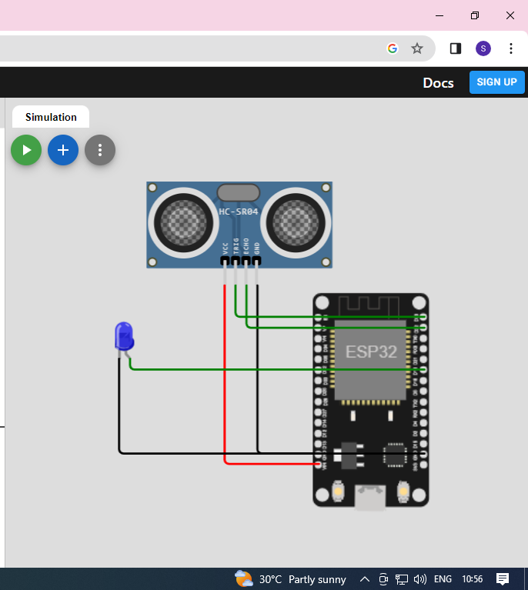

**OUTPUT :**

